LLM used to generate code: Claude Opus 5.5 (Effort level = Medium)
Programming language: OCaml

Prompts (Note: Some prompts do not make sense without the accompanying LLM outputs. However, this file would be much longer if each turn were pasted in.):
- linear_decay <- function(x){exp(1/x)}
ggplot(data.frame(x=c(1, 6)), aes(x=x)) +
stat_function(fun=linear_decay)
Plot this R code in OCaml
- can you run the code to make sure it works?
- 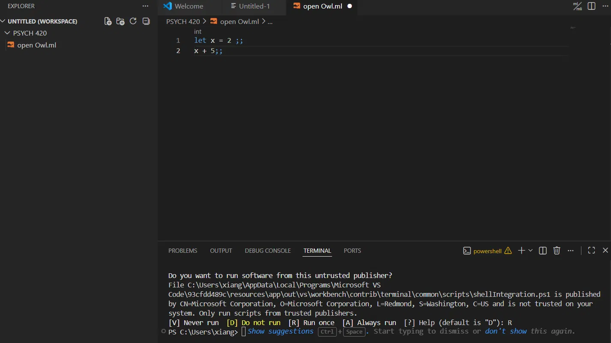
how do I run this on my vs code environment?
- How do I run the exponential decay code in vs code
- Why do I need to create a new folder with no spaces in its name? What's wrong with the current folder?
- 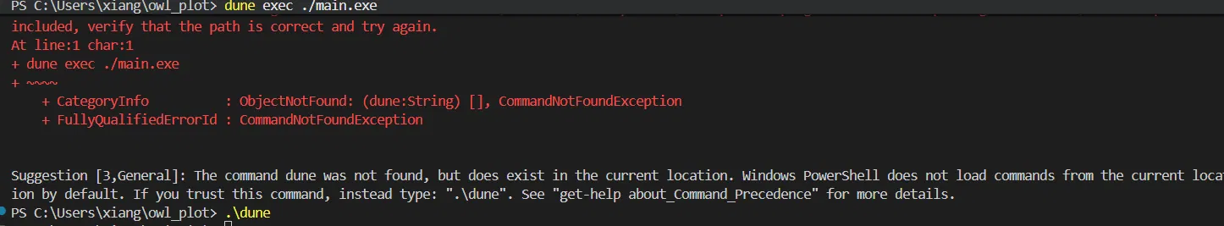
For context: This is on a window's machine
- 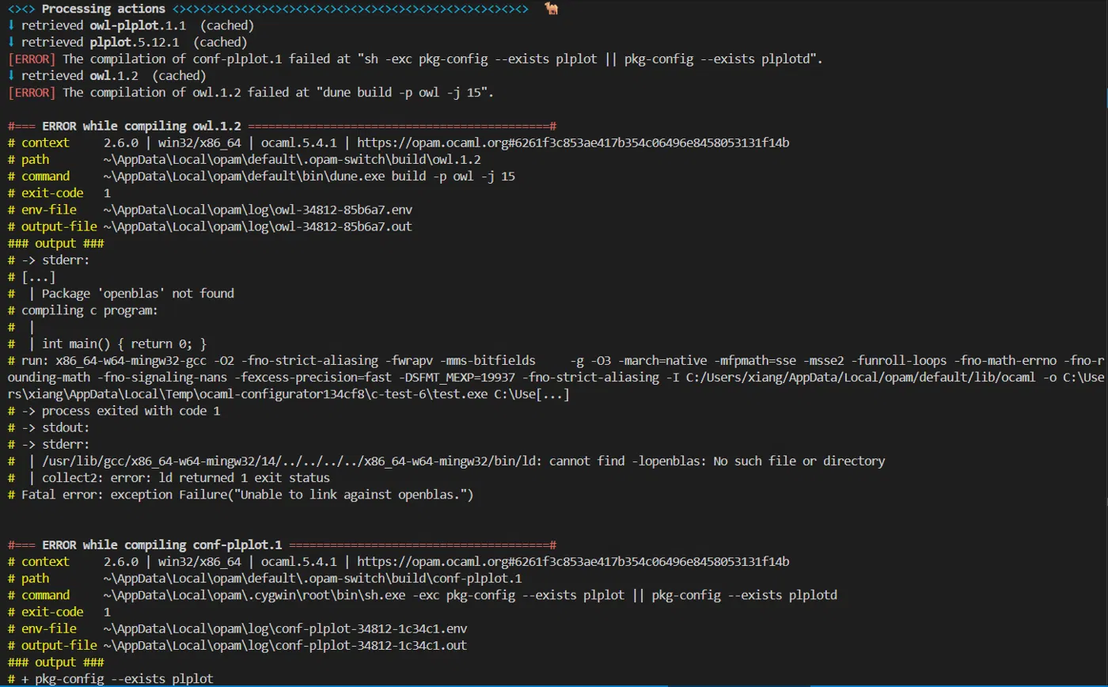
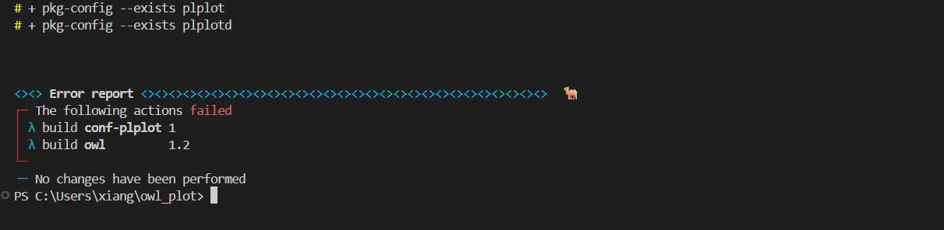
What do these error messages mean?
- what if I am insistent on running this in windows
- which version of ubuntu should I be using in WSL?
- 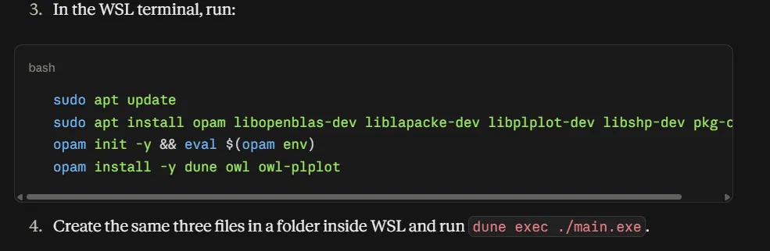
what do you mean by 4.? Do i need to make another folder and replicate the files?
- 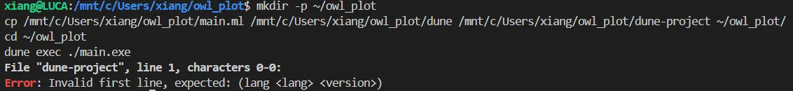
- 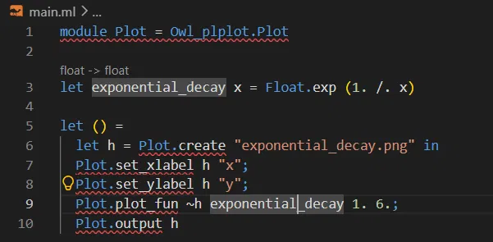
I'm still seeing underlined code related to owlplot's functions.
- 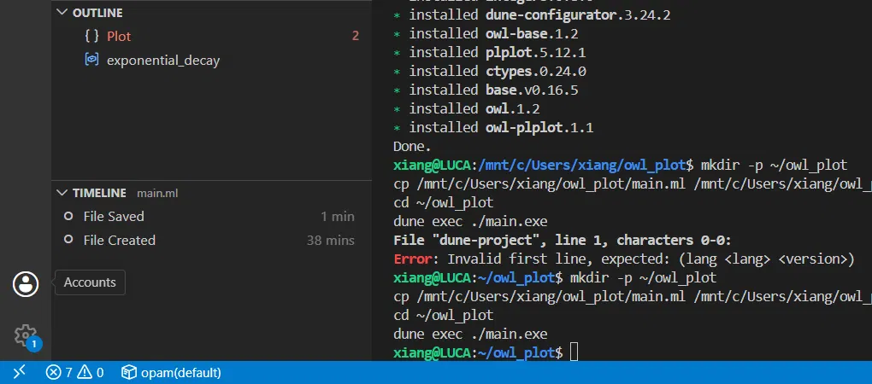
Is VS Code not connected to WSL?
- It works, but is there a solution that works in a single file?
- How would i put that into a separate file
Tools needed:
- Visual Studio Code (VS Code)
- The OCaml extension in VS Code
- The WSL extension in VS Code (only applicable for computers running Windows)
Note: We also went through the OCaml documentation separately when installing OCaml and trying to integrate it into VS Code. The R code was adapted from https://www.statology.org/plot-equation-in-r/ (Example 2)
library(ggplot2)

#define equation
my_equation <- function(x){2*x^2+5}

#plot equation
ggplot(data.frame(x=c(1, 50)), aes(x=x)) +
stat_function(fun=my_equation)

